## **Objectives**

* Explain React components
* Identify the differences between components and JavaScript functions
* Identify the types of components
* Explain class component
* Explain function component
* Define component constructor
* Define render() function

In this hands-on lab, you will learn how to:

* Create a function component
* Apply style to components
* Render a component

## **Prerequisites**

The following is required to complete this hands-on lab:

* Node.js
* NPM
* Visual Studio Code

## **Notes**

Estimated time to complete this lab: **30 minutes.**

Create a react app for Student Management Portal named scorecalculatorapp and create a function component named “CalculateScore” which will accept Name, School, Total and goal in order to calculate the average score of a student and display the same.

1. Create a React project named “scorecalculatorapp” type the following command in terminal of Visual studio:



1. Create a new folder under Src folder with the name “Components”. Add a new file named “CalculateScore.js”
2. Type the following code in CalculateScore.js

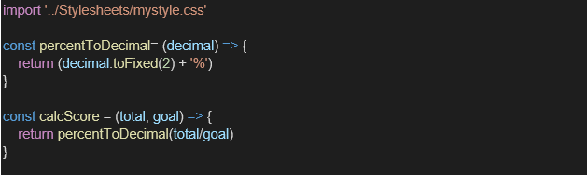

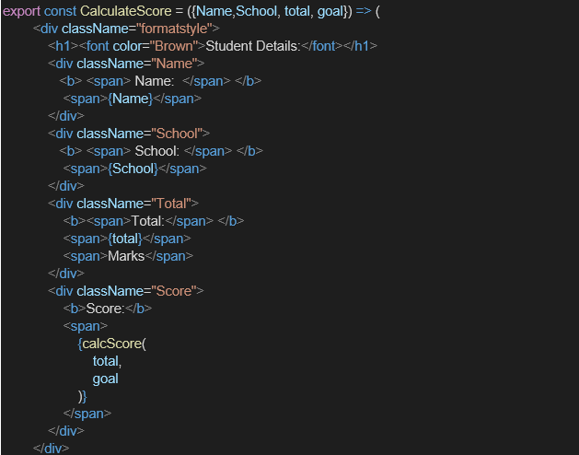

1. Create a Folder named Stylesheets and add a file named “mystyle.css” in order to add some styles to the components:

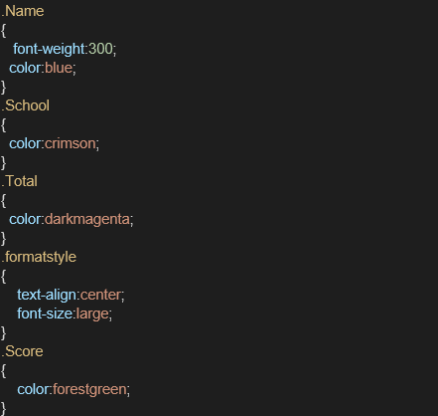

1. Edit the App.js to invoke the CalculateScore functional component as follows:

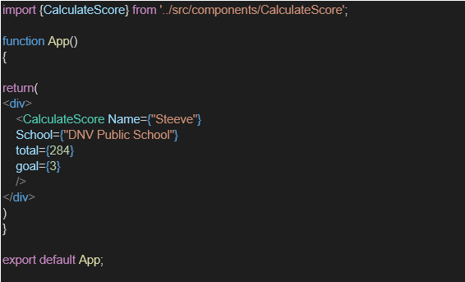

1. In command Prompt, navigate into scorecalculatorapp and execute the code by typing the following command:



1. Open browser and type “localhost:3000” in the address bar:

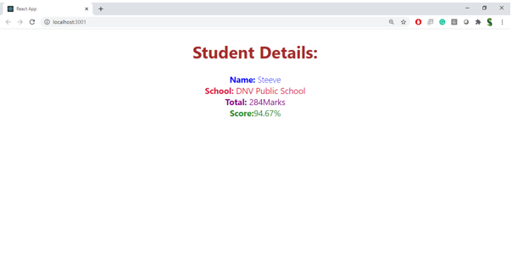**Output:**

